FRANCE BY TRAIN
WITH VOYAGES-SNCF
CONTENT

1. SPA 4
NORMANDY: DEAUVILLE 4
BRITTANY: SAINT MALO, LA BAULE AND RENNES 4
THE AQUITAINE COAST : ARCACHON, BIARRITZ AND BORDEAUX 5
2. HERITAGE 6
NORMANDY: MONT SAINT MICHEL 6
THE CASTLES OF THE LOIRE VALLEY 7
THE SOUTH 8
3. GASTRONOMY & WINE 9
BORDEAUX 9
FRENCH CHEFS & GREAT WINES 10
ALSACE 11
4. FAMILY 12
FUTUROSCOPE & POITOU CHARENTES 12
AUVERGNE & THE VOLCANO COUNTRY 13

REFERENCES

Regional trains – the best way to travel around regions and less accessible areas
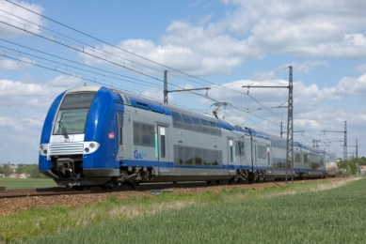
Traditional French trains – day and night networks
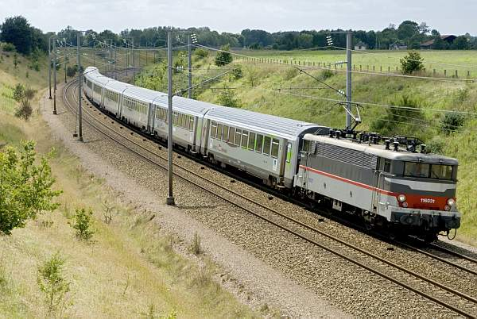
High-speed trains – make your travel from one city to another easy and fast
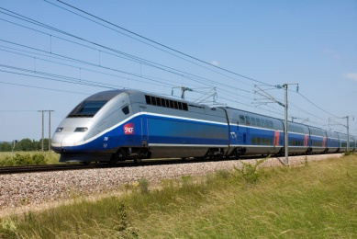

* Best journey time
** Conditions apply – maximum number of trains in high-peak season

1. SPA

NORMANDY: DEAUVILLE
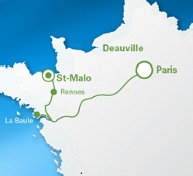
Discover the sandy beaches of Deauville, well-known for its wellness centers – only two hours away from Paris! Enjoy a well-deserved break from the city hassle and treat yourself at one of the many spa resorts.
PARIS MONTPARNASSE – DEAUVILLE
- 2h00* with Intercités
up to 3 trains a day**

BRITTANY: SAINT MALO, LA BAULE AND RENNES
Head off to one of the most visited parts of France and get a taste of the salty air of the North Atlantic Coast – the TGV high-speed train brings you to the heart of a region known for its breath-taking cliffs and postcard landscapes.
PARIS MONTPARNASSE – SAINT-MALO
- 2h58* with TGV
up to 4 trains a day**
OR
- 3h12* with TER and TGV via Rennes
up to 10 trains a day**

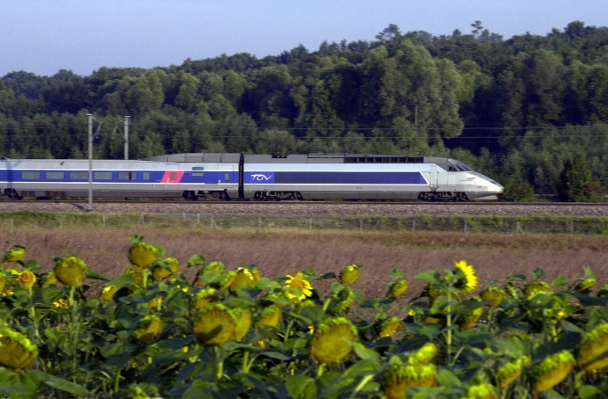
THE AQUITAINE COAST : ARCACHON, BIARRITZ AND BORDEAUX
PARIS MONTPARNASSE – RENNES
- 2h09* with TGV
up to 20 trains a day**

PARIS MONTPARNASSE – LA BAULE
- 3h01* with TGV
up to 3 trains a day**

Relax and take advantage of what the seaside has to offer: attractive beaches, mild climate, sea sports and numerous spas. Indulge yourself with Bordeaux finest selection of wine and high-range cuisine.
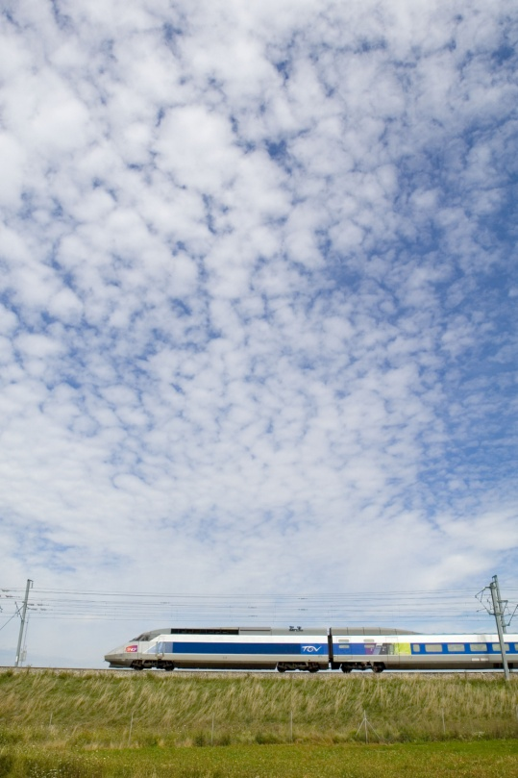
PARIS MONTPARNASSE – BORDEAUX
- 3h10* with TGV
up to 21 a day**

PARIS MONTPARNASSE – ARCACHON
- 3h53* with TGV
up to 2 a day**

PARIS MONTPARNASSE – BIARRITZ
- 5h10* with TGV
up to 4 a day**

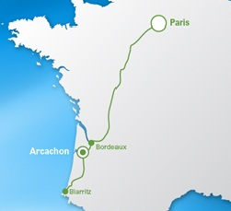

2. HERITAGE

NORMANDY: MONT SAINT MICHEL
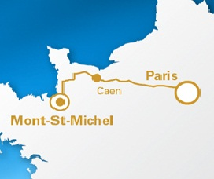
One of the « West Wonders », the Mont Saint Michel is a fortified tidal island listed on the UNESCO Heritage. Ideally located between Normandy and Brittany it represents medieval architecture at its best.
PARIS MONTPARNASSE – RENNES
- 2h09* with TGV + coach to the site
up to 20 trains a day**

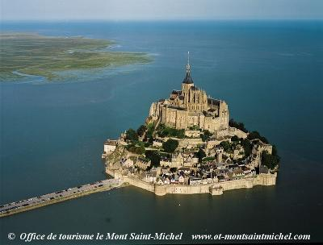

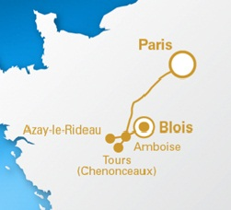
THE CASTLES OF THE LOIRE VALLEY
The Loire River Valley is home to dozens of fairytale castles. Embark on a journey back in time along the favourite riverbeds of the French Kings. Discover the rich national historical treasures that highlight the route – no wonder that the UNESCO listed it as a World Heritage Site.
PARIS MONTPARNASSE – SAINT-PIERRE-DES-CORPS (TOURS)
- 1h00* with TGV
up to 15 trains a day**

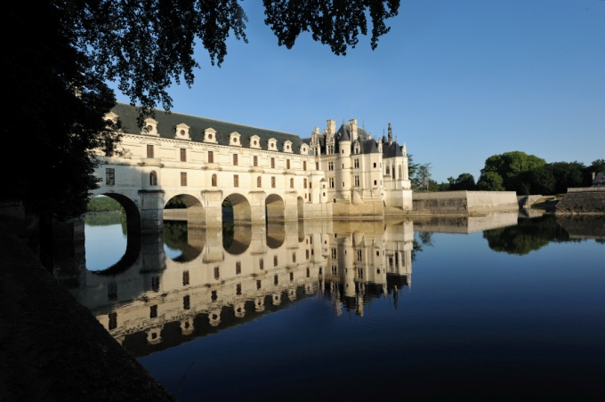
TOURS – AZAY-LE-RIDEAU
- 0h30* with TER
up to 9 trains a day**
© Images de Marc

TOURS – CHENONCEAU
- 0h30* with TER
up to 10 trains a day**
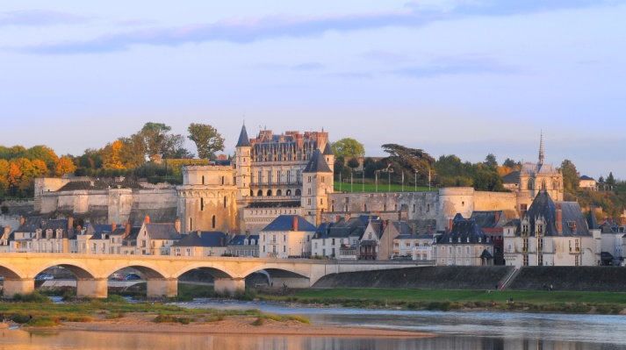
© L. de Serres

TOURS – AMBOISE
- 0h20* with TER
up to 19 trains a day**

THE SOUTH
Endless lavender fields, the deep blue sea and its breath-taking coastline, the song of cicadas and the art of living to the full: welcome to the South of France, where joie de vivre and comfort are no hollow words. Visit Avignon’s medieval Cité des Papes and get a taste of the cosmopolitan feel of Marseille.
AIX-EN-PROVENCE - MARSEILLE
- 0h11* with TGV
up to 22 trains a day**
PARIS GARE DE LYON - AVIGNON
- 2h45* with TGV
up to 4 trains a day**
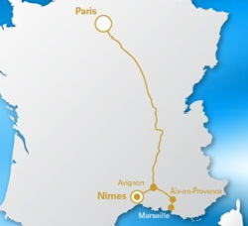
AVIGNON – AIX-EN-PROVENCE
- 0h24* with TGV
up to 19 trains a day**

MARSEILLE - NÎMES
- 0h58* with TGV, TER or Intercités
up to 11 trains a day**

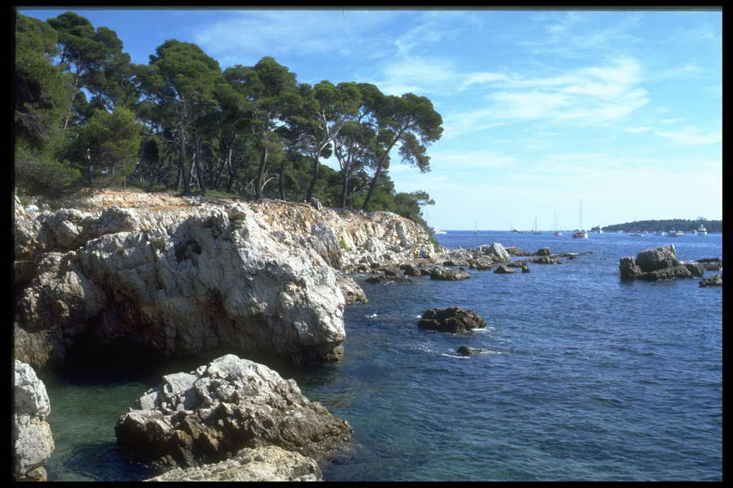
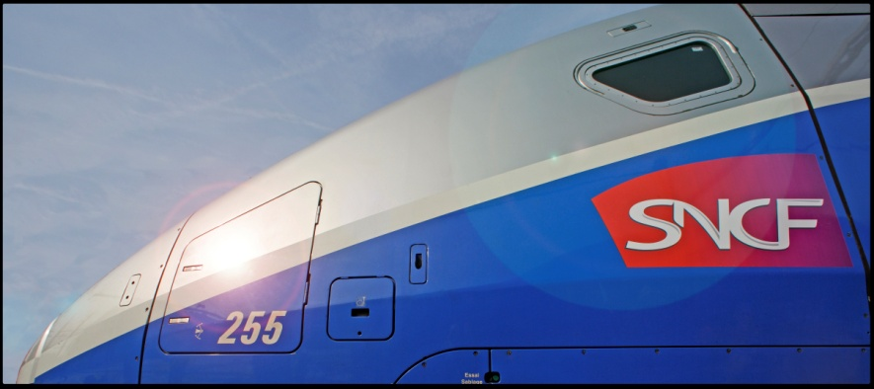

3. GASTRONOMY & WINE

BORDEAUX
Tasty food and traditional wine: mouth-watering delights that make your palate languish for more. This route brings you to the heart of the Bordeaux vineyards, along the Garonne River, right at the foot of the Pyrenees.
PARIS MONTPARNASSE – BORDEAUX
- 3h10* with TGV
up to 21 trains a day**

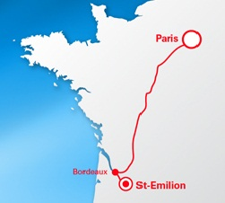
BORDEAUX – SAINT-EMILION
- 0h37* with TER
up to 9 trains a day**

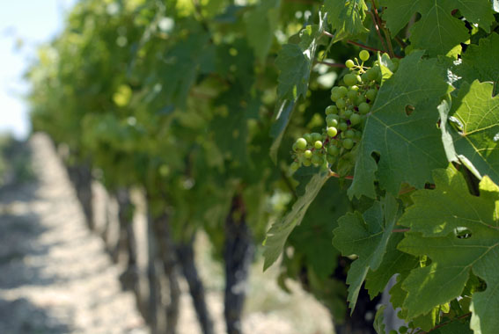

FRENCH CHEFS & GREAT WINES
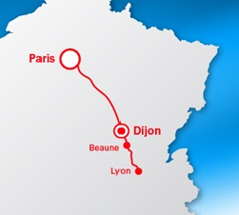
Visit Lyon and its « bouchons », small unpretentious restaurants which serve traditional dishes – you won’t find haute cuisine here but a great atmosphere and real food specialties. Dijon and Burgundy have much more to offer than mustard: think of snails, “boeuf bourguignon” (Burgundy beef) and if you have the chance, try the wine auction in Beaune.
BEAUNE - DIJON
- 0h20* with TER
up to 45 trains a day**

LYON - BEAUNE
- 1h40* with TER
up to 16 trains a day**

PARIS GARE DE LYON – LYON PART DIEU
- 2h00* with TGV
up to 22 trains a day**

DIJON – PARIS GARE DE LYON
- 1h36* with TGV
up to 10 trains a day**

ALSACE
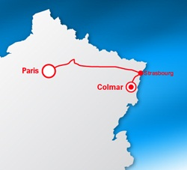
At the crossroads of cultures the region still proudly retains its own language and heritage. The Rhine River runs through gentle valleys and hilly landscapes. This enchanting scenery makes you crave for a wide choice of local produce such as Crémant d’Alsace, a sparkling white wine – Alsace is also well-known for its “Kougelhopf” (a raisins and almonds cake) and its traditional “choucroute”.

PARIS EAST - STRASBOURG
- 2h20* with TGV
up to 16 trains a day**

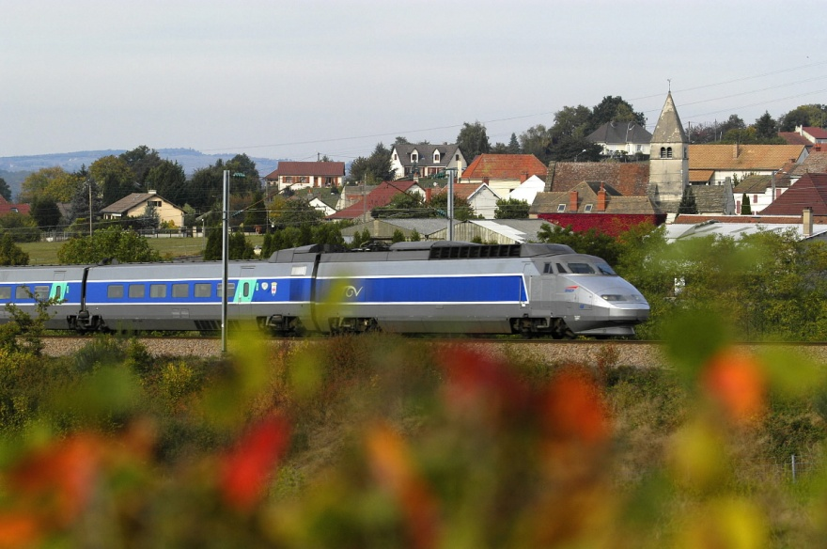

STRASBOURG - COLMAR
- 0h30* with TER
up to 32 trains a day**

COLMAR – PARIS EAST
- 2h51* with TGV
up to 4 trains a day**

4. FAMILY

FUTUROSCOPE & POITOU CHARENTES
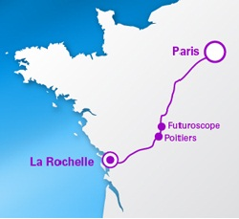
Take your family to Futuroscope, one of the biggest and most interactive amusement parks in Europe dedicated to technology and multimedia. A few kilometers away the city of Poitiers awaits you with a wide range of outdoor activities such as canoeing, water-skiing and many more. Go further south and have a stroll in La Rochelle with its fairytale-like history of pirates and battles.
FUTUROSCOPE TGV - POITIERS
- 0h07* with TER
up to 5 trains a day**

POITIERS – LA ROCHELLE
- 1h16* with TGV
up to 6 trains a day**

PARIS MONTPARNASSE – FUTUROSCOPE TGV
- 1h22* with TGV
up to 2 trains a day**
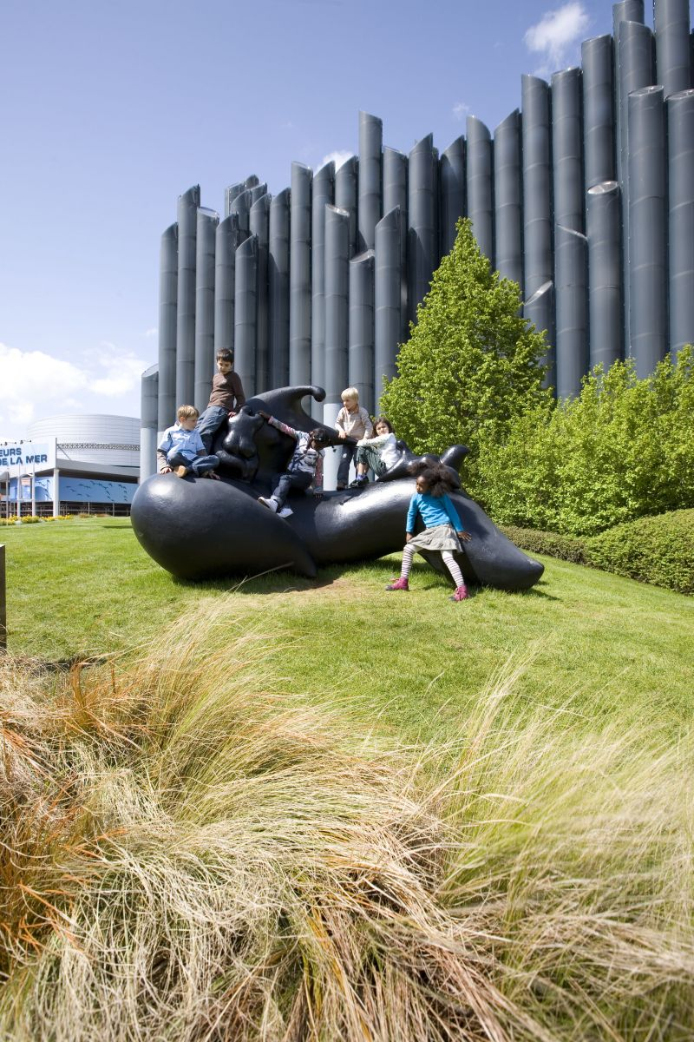
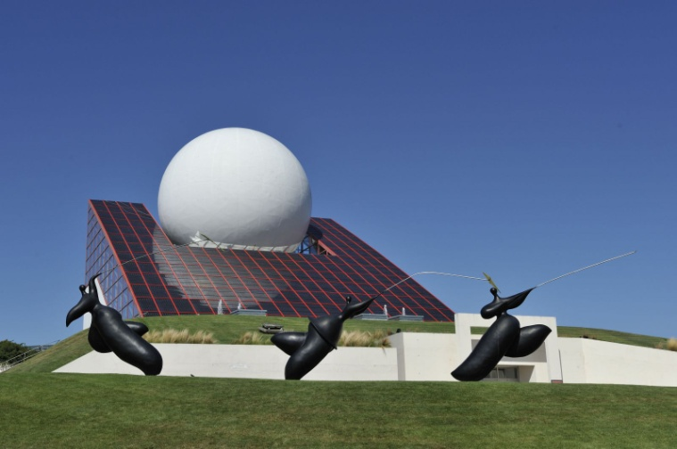
© Futuroscope / G. Buthaud / Toutain / D.LAMING Architecte

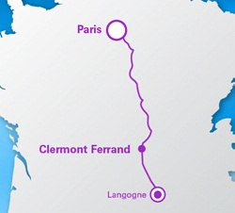
AUVERGNE & THE VOLCANO COUNTRY
Auvergne’s landscapes are dominated by water springs and volcanoes. Don’t be afraid though: volcanoes have long been dormant and are the perfect starting point of walks and many other outdoor activities. Ideal for family trips with children.
CLERMONT FERRAND – LANGEAC
- 1h29* with TER
up to 3 trains a day**

PARIS GARE DE LYON – CLERMONT FERRAND
- 3h07* with Intercités
up to 8 trains a day**

