ON THE WINE TRACK
WITH VOYAGES-SNCF

DISCOVERING WINES BY TRAIN

Summer is almost gone but the wine season has just begun! Before winter hits you down and makes you feel like staying warm and cozy at home, follow the tracks of the great vineyard regions of France…all of them accessible by train for your greatest comfort. A whole network of high-speed, regional and intercity trains connects you to the heart of the country of the “Grands Crus”. Are you an aficionado, an amateur or simply eager to learn more? Book now your wine route by train. Your journey starts onboard, with a good glass of the finest red.

1. BOURGOGNE 3
2. JURA / FRANCHE-COMTÉ 4
3. ALSACE 5
4. CHAMPAGNE 6
5. LANGUEDOC – ROUSSILLON 7
6. POITOU – CHARENTES 8
7. VAL DE LOIRE 9

BOURGOGNE
Paris – Beaune
Paris Gare de Lyon – Beaune
With TGV and TER
Up to 6 trains a day
From € 15
Best travel time: 2h09

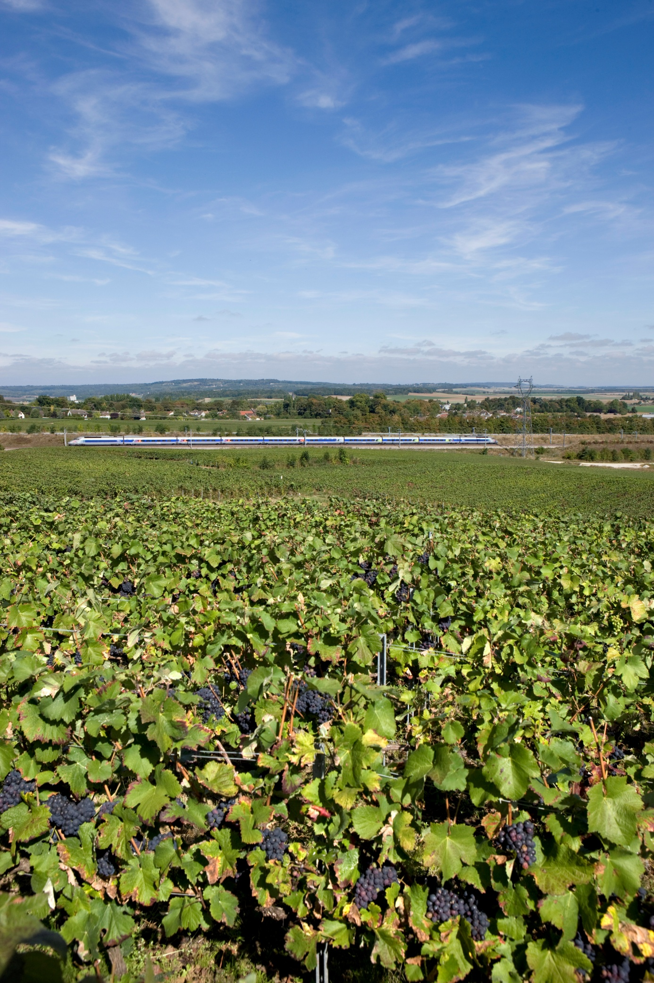

Paris – Dijon
Paris Gare de Lyon – Dijon
With TGV and TGV Lyria
Up to 17 trains a day
From € 15
Best travel time: 1h35

TIP:
Hospices de Beaune
Wine Museum in Beaune

JURA / FRANCHE-COMTÉ

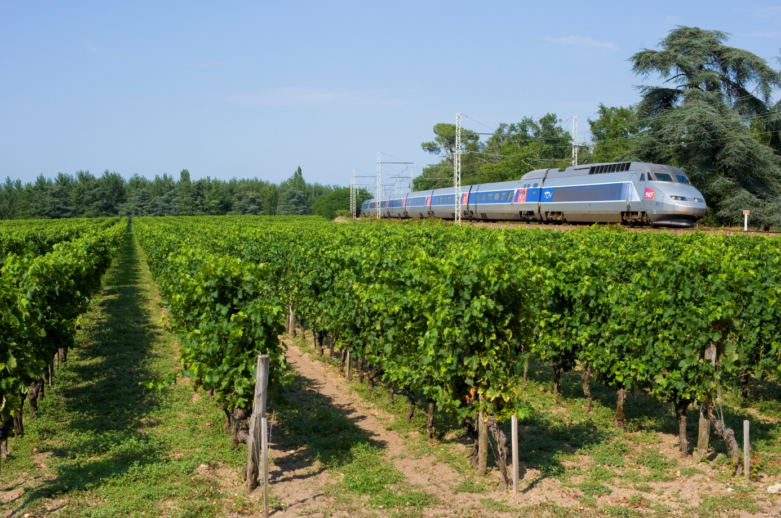

Paris – Besançon
Paris Gare de Lyon – Besançon
With TGV
Up to 10 trains a day
From € 20
Best travel time: 1h59

Paris – Lons-le-Saunier
Paris Gare de Lyon – Lons-le-Saunier
With TGV, TGV Lyria, TER and Intercités night trains
Up to 16 trains a day
From € 33.90
Best travel time: 2h48

ALSACE

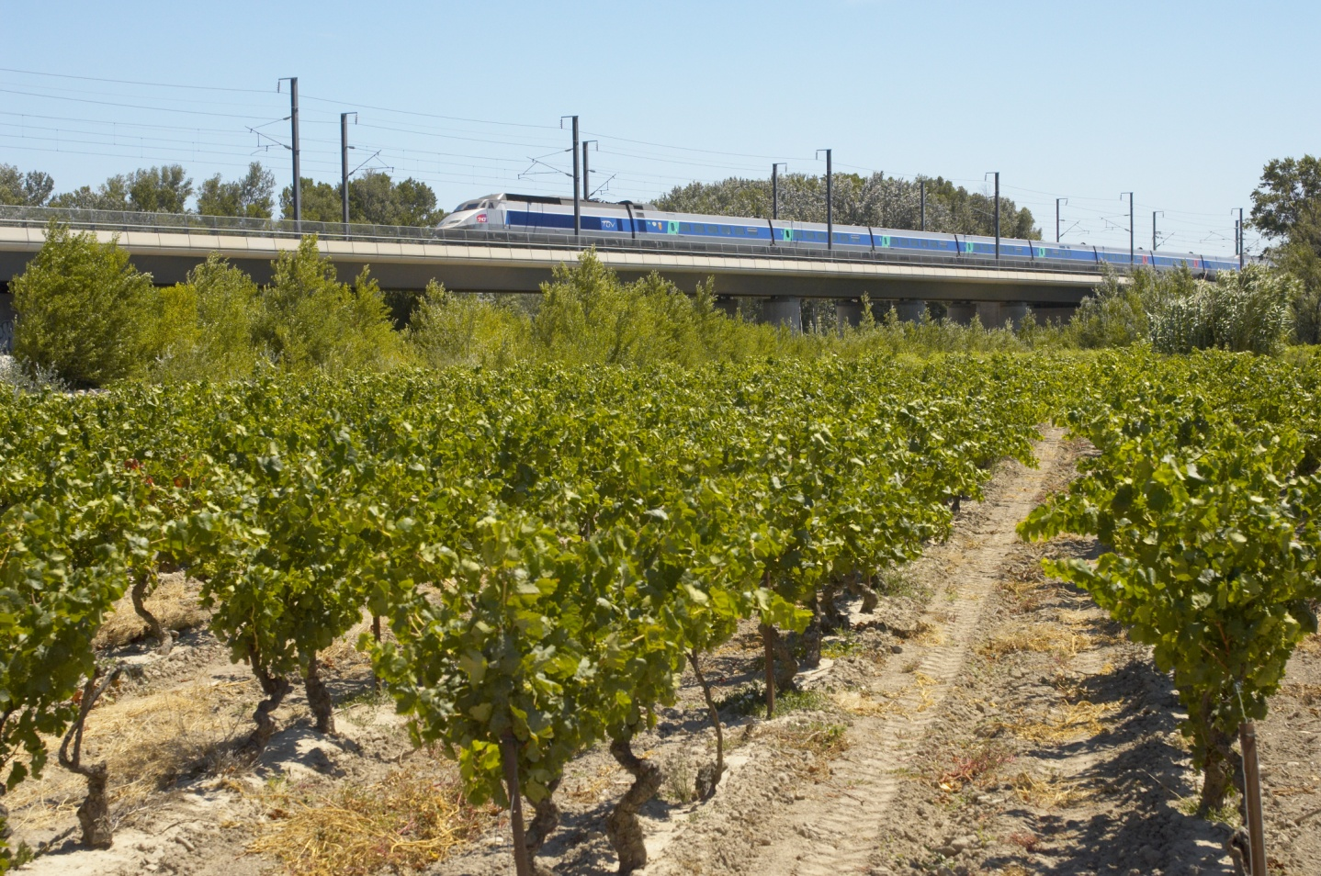

Strasbourg – Colmar
With TER
Up to 32 trains a day
€ 11.70
Best travel time: 30 mins
Strasbourg – Saverne
With TER
Up to 42 trains a day
€ 8.60
Best travel time: 22 mins

Paris – Strasbourg
Paris Gare de l’Est – Strasburg
With TGV
Up to 21 trains a day
From € 38
Best travel time: 2h20

TIP:
Alsace has more wine sorts than any other region in France: Pinot Noir, Pinot Blanc, Muscat, Riesling, Sylvaner…you name it!

CHAMPAGNE

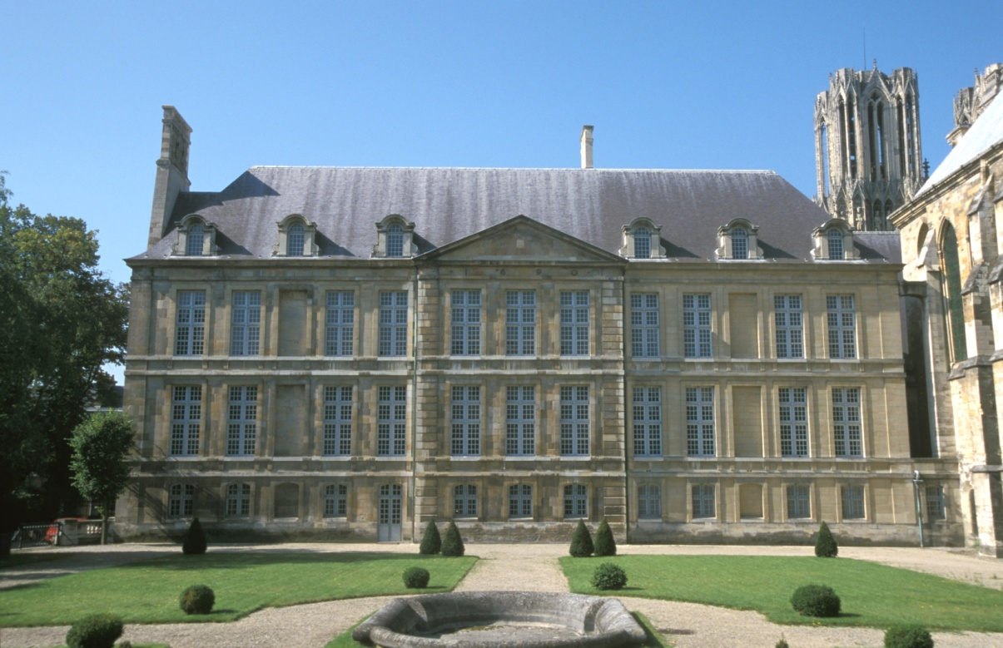

Paris – Reims
With TGV and TER
Up to 17 trains a day
From € 15
Best travel time: 0h40

Reims – Epernay
With Intercités
Up to 22 trains a day
From € 5.90
Best travel time: 0h17

TIP:
Veuve Cliquot – taste one of the finest at this world-renowned and well-established house /// Epernay = the capital of champagne!

LANGUEDOC – ROUSSILLON

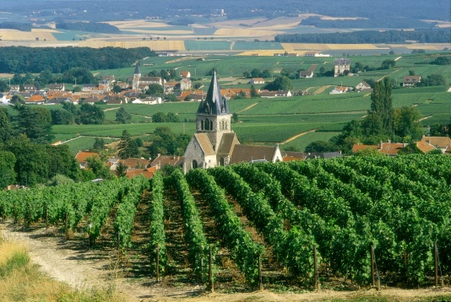
Paris – Nîmes
Paris Gare de Lyon – Nîmes
With TGV and Intercités night trains
Up to 20 trains a day
From € 25
Best travel time: 2h51

Paris – Montpellier
Paris Gare de Lyon – Montpellier
With TGV and Intercités night trains
Up to 21 trains a day
From € 25€
Best travel time : 3h20

POITOU – CHARENTES
Paris – Angouleme
Paris Montparnasse – Angouleme
With TGV
Up to 16 trains a day
From € 30
Best travel time: 2h19

Angouleme – Cognac
With TER and Intercités
Up to 11 trains a day
From 9.50€
Best travel time: 30 mins

TIP:
Poitou Charentes is best known for its amber-coloured aquavits: Cognac and Pineau des Charentes

VAL DE LOIRE
Paris – Chinon
Paris Montparnasse via Tours – Chinon
With TGV and TER
Up to 7 trains a day
From € 24.20
Best travel time: 2h11

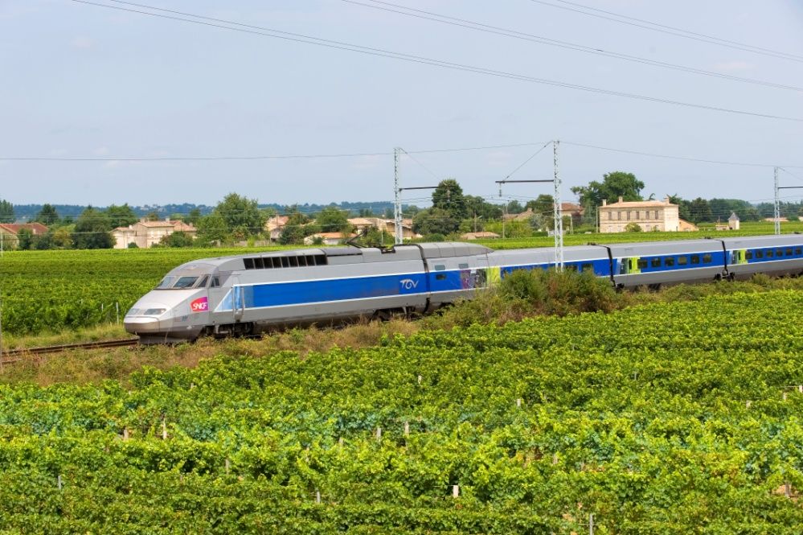

Paris – Nantes
Paris Montparnasse – Nantes
With TGV
Up to 27 trains a day
From € 20
Best travel time: 2h11

TIP:
Val de Loire Region organises 14 walks around its UNESCO-registered vineyards – take a break and enjoy a wine-tasting session along the way.

